**Project Design Phase-II**

**Data Flow Diagram & User Stories**

|  |  |
| --- | --- |
| Date | 31 January 2025 |
| Team ID | LTVIP2025TMID34696 |
| Project Name | Enchanted Wings: Marvels Of Butterfly Species |
| Maximum Marks | 4 Marks |

**Data Flow Diagrams:**

A Data Flow Diagram (DFD) is a traditional visual representation of the information flows within a system. A neat and clear DFD can depict the right amount of the system requirement graphically. It shows how data enters and leaves the system, what changes the information, and where data is stored.

**Example:** [**(Simplified)**](https://developer.ibm.com/patterns/visualize-unstructured-text/)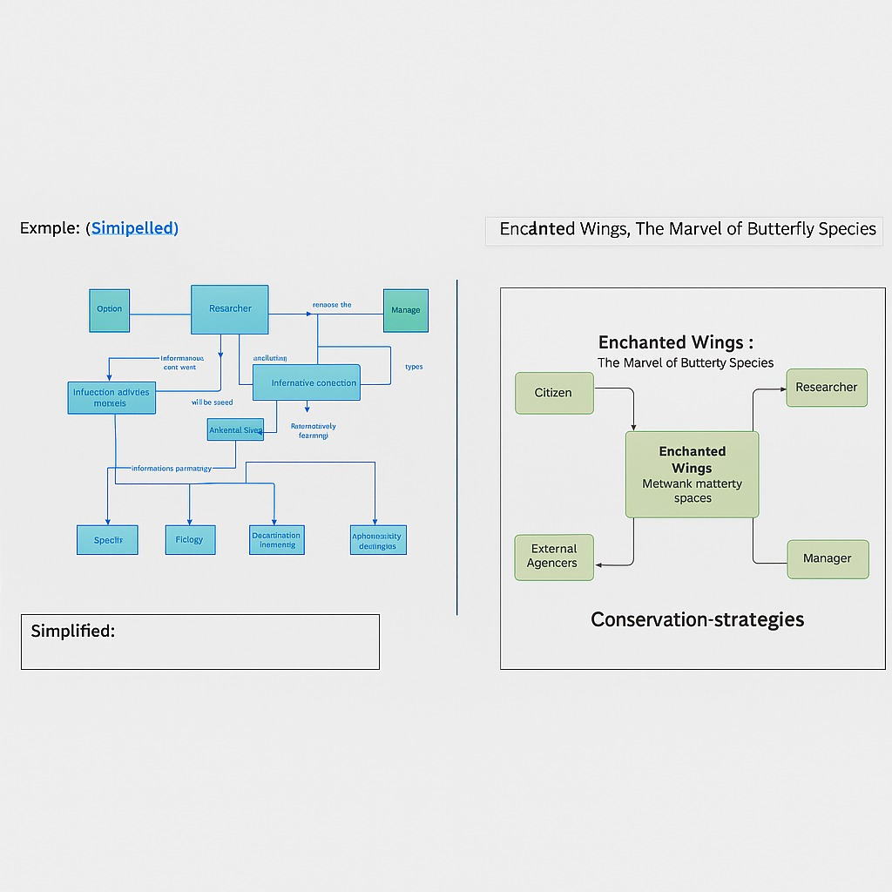

**User Stories**

Use the below template to list all the user stories for the product.

| **User Type** | **Functional Requirement (Epic)** | **User Story Number** | **User Story / Task** | **Acceptance criteria** | **Priority** | **Release** |
| --- | --- | --- | --- | --- | --- | --- |
| Data Engineer | Data Integration | USN-1 | As a developer, I want to collect and integrate butterfly images and labels from CSV and folders | All raw data is organized and image paths are mapped to labels | High | Sprint-1 |
| Data Engineer | Data Preprocessing | USN-2 | As a developer, I want to clean, resize, and prepare the dataset for model input | |  | | --- | | Dataset is resized, augmented, and split into train/test sets |  |  | | --- | |  | | High | Sprint-1 |
| ML Engineer | Model Building | USN-3 | |  | | --- | | As a developer, I want to train a transfer learning model (e.g., VGG16) to classify butterfly species |  |  | | --- | |  | | |  | | --- | | Model trains without overfitting and achieves >80% accuracy |  |  | | --- | |  | | High | Sprint-2 |
| |  | | --- | | ML Engineer |  |  | | --- | |  | | Model Evaluation | USN-4 | |  | | --- | | As a developer, I want to evaluate the model performance on unseen test data |  |  | | --- | |  | | |  | | --- | | Evaluation metrics (accuracy, confusion matrix) are documented |  |  | | --- | |  | | Medium | Sprint-2 |
| |  | | --- | | DevOps Engineer |  |  | | --- | |  | | |  | | --- | | Model Deployment |  |  | | --- | |  | | |  | | --- | | USN-5 |  |  | | --- | |  | | |  | | --- | | As a developer, I want to deploy the trained model using Flask for prediction via web interface |  |  | | --- | |  | | |  | | --- | | Model deployed and accessible via a prediction API or webpage |  |  | | --- | |  | | |  | | --- | | High |  |  | | --- | |  | | |  | | --- | | Sprint-3 |  |  | | --- | |  | |
| |  | | --- | | Admin |  |  | | --- | |  | | |  | | --- | | Dashboard Monitoring |  |  | | --- | |  | | |  | | --- | | USN-6 |  |  | | --- | |  | | |  | | --- | | As an admin, I want to view model performance metrics and upload new images through a secure dashboard |  |  | | --- | |  | | |  | | --- | | Dashboard shows prediction logs and upload interface |  |  | | --- | |  | | |  | | --- | | Medium |  |  | | --- | |  | | |  | | --- | | Sprint-4 |  |  | | --- | |  | |
| |  | | --- | | Researcher |  |  | | --- | |  | | |  | | --- | | Biodiversity Analysis |  |  | | --- | |  | | |  | | --- | | USN-7 |  |  | | --- | |  | | |  | | --- | | As a researcher, I want to analyze species prediction reports to understand butterfly population trends |  |  | | --- | |  | | |  | | --- | | Reports generated with time stamps and location metadata |  |  | | --- | |  | | |  | | --- | | Medium |  |  | | --- | |  | | |  | | --- | | Sprint-4 |  |  | | --- | |  | |
| |  | | --- | | Nature Enthusiast |  |  | | --- | |  | | |  | | --- | | Species Identification |  |  | | --- | |  | | |  | | --- | | USN-8 |  |  | | --- | |  | | |  | | --- | | As a user, I want to upload a butterfly image and get the predicted species |  |  | | --- | |  | | |  | | --- | | Species name and confidence score are shown after upload |  |  | | --- | |  | | |  | | --- | | High |  |  | | --- | |  | | |  | | --- | | Sprint-3 |  |  | | --- | |  | |
| |  | | --- | | Third-party App Dev |  |  | | --- | |  | | |  | | --- | | API Integration |  |  | | --- | |  | | |  | | --- | | USN-9 |  |  | | --- | |  | | |  | | --- | | As a developer, I want access to the classification API for use in external conservation apps |  |  | | --- | |  | | |  | | --- | | API provides response within 2s and returns top-3 predictions |  |  | | --- | |  | | High | Sprint-4 |